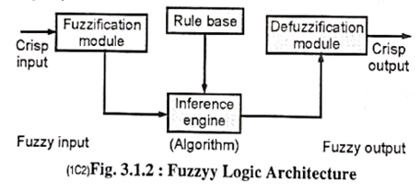

Properties of Fuzzy Logic Set

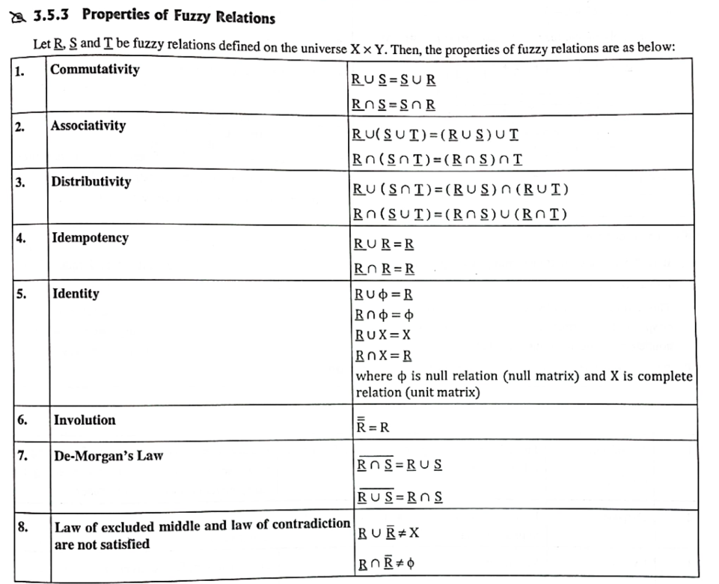

Operations

Operations on Fuzzy Set

Given Ã and B are the two fuzzy sets, and X be the universe of discourse with the following respective member functions:

Fuzzy Logic Tutorial

The operations of Fuzzy set are as follows:

1. Union Operation: The union operation of a fuzzy set is defined by:

μA∪B(x) = max (μA(x), μB(x))

Example:

Let's suppose A is a set which contains following elements:

A = {( X1, 0.6 ), (X2, 0.2), (X3, 1), (X4, 0.4)}

And, B is a set which contains following elements:

B = {( X1, 0.1), (X2, 0.8), (X3, 0), (X4, 0.9)}

then,

AUB = {( X1, 0.6), (X2, 0.8), (X3, 1), (X4, 0.9)}

2. Intersection Operation:The intersection operation of fuzzy set is defined by:

μA∩B(x) = min (μA(x), μB(x))

Example:

3. Complement Operation: The complement operation of fuzzy set is defined by:

μĀ(x) = 1-μA(x),

4. Alegbraic sum: a+b-a.b

5. Algebraic product a.b

6. Bounded sum: min(1,a+b)

7. Bounded difference: max(1, a-b)

Composition of fuzzy relations

1. Max-min composition
2. Max-product composition

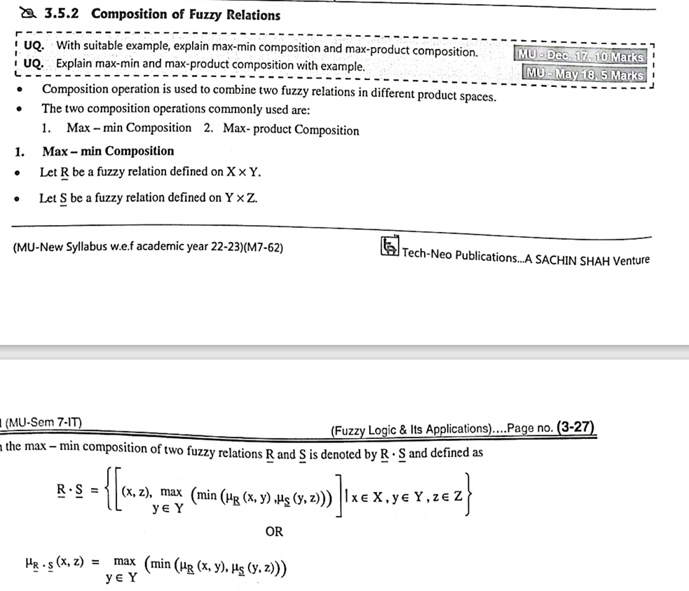

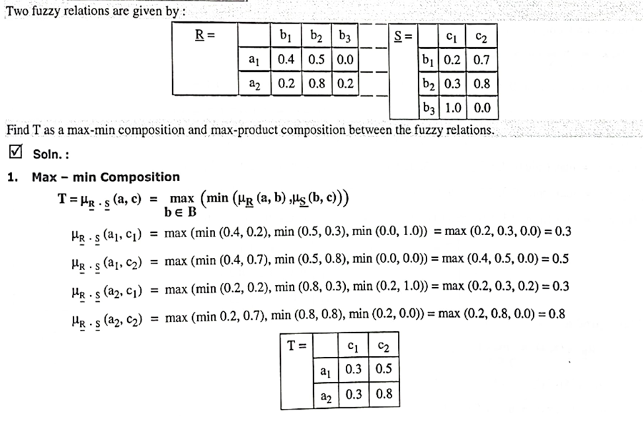

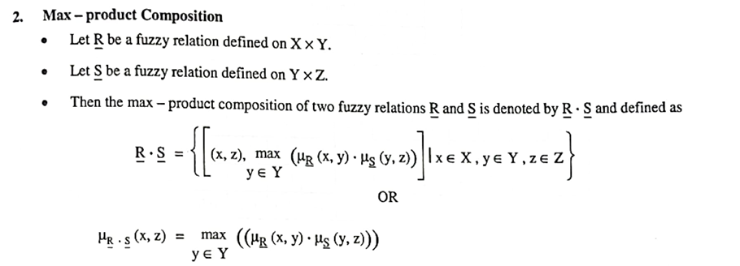

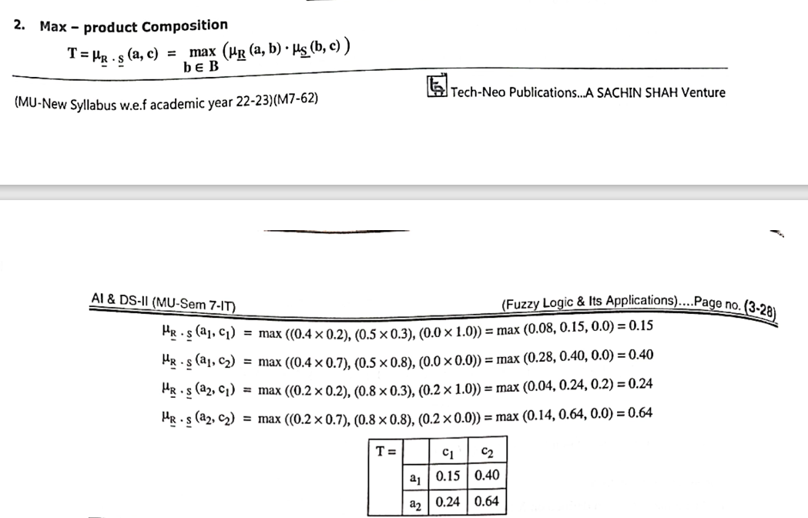

Fuzzy Membership function - pg 73

1. Singleton
2. Triangular
3. Trapezoidal
4. Increasing
5. Decreasing
6. Gaussian

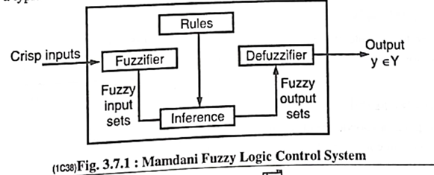

* To control a steam engine and boiler controller